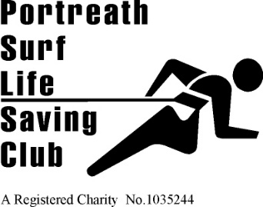 | 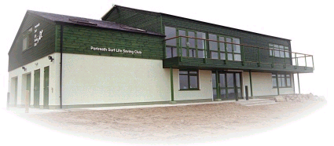 | Founded 1958  Affiliated to  Surf Life Saving Cornwall and the Surf Life Saving Association of Great Britain  HEADQUARTERS  Portreath Beach, Portreath, Cornwall UK.  WEBSITE  www.portreathslsc.co.uk

Please use this form to find out if the club is available and what the applicable fees would be, once we have confirmed availability you will need to complete a booking form to secure it.

Hirer’s contact details: Member / Non Member

Contact name
Organisation/e.g. function
email
Phone number
Rooms to hire:
Main room including Kitchen
Booking Details:
Preferred Date
Is the licenced bar required.
Time room access required from
Time room access required until
Number of people expected
Other Requirements: Specify

