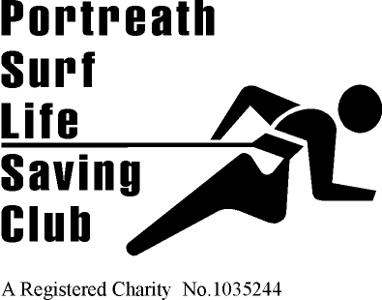

Masters & Seniors COMPETITION ENTRY REQUEST FORM 2017

National Championships Holywell Bay/ Portreath

NAME ____________________________

D.O.B. ____________________________

Masters National Championships, 12th – 13th August Holywell Bay £26. Returned by 24th July

Senior National Championships 26th – 27th August Portreath £6 per event, or £26 for 4+ events. Returned by 7th August
Please tick events you wish to be entered.

Surf Race Board Race
Ski Race Ironman/woman
Flags Sprint
1km 2km (senior)

Total enclosed £ ______

Please make all cheques payable to Portreath SLSC

Or pay by BACS sort 30-97-00 a/c 00174435 name as reference, email to team manager and Susan Bray.

Any questions about any competitions please do not hesitate in speaking to one of the team managers.

Charlotte Savage chuckysavage@hotmail.com Club Captain
Chantel Richards chanrichards123@gmail.com Masters Manager
Susan Bray susanbray@yahoo.co.uk Treasurer

