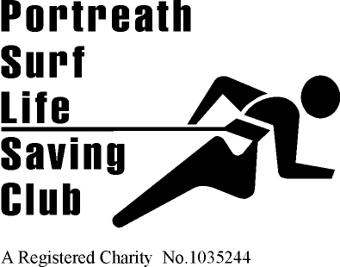 | 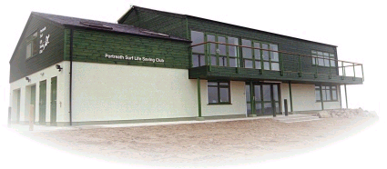 | Founded 1958  Affiliated to  Surf Life Saving Cornwall and the Surf Life Saving Association of Great Britain  HEADQUARTERS  Portreath Beach, Portreath, Cornwall UK.  Tel. 07808 912273  WEBSITE  www.portreathslsc.org.uk  Gold Coast

Club Training Sessions and Valid Insurance Cover for 2017.

The terms of our insurance providing Public and Products Liability, Personal Accident and Travel Cover to all our members and Trainers for all SLSGB approved club training activities relies on a duty of care that needs to be supported by clubs adopting a best practise framework for ALL the training sessions.

This not only requires that risk assessments are undertaken and other conditions are set out in the SLSGB National Safety Guide is undertaken but also and importantly that properly qualified coaches plan and deliver the sessions.

This means that EVEY CLUB must be using a Level 2 Coach or, if appropriate a Trainer Assessor as the session lead who may be supported by a level 1 coach or parent helper as required.

COACHING – EXPLANATION ABOUT THE LEVEL 2 COACH
Why Training should not be managed by a Lifeguard or a TA without Level 2 Coach training
A Surf lifeguard is qualified to make risk assessments that relate to whether or not it is safe for people to use the beach and to advise on the use of the beach and to respond to those who need assistance or may be in difficulty. If a rescue response is required they should not act on their own and should be part of a team, each person of which will have a role in that response. Their role is to establish if it is safe to run a training session and to provide safety cover. They are not trained to plan a session or to coach.
Nobody is saying that what most clubs do in managing training sessions is unsafe. The problem is that SLSGB has only focused in the past on the development of Educators and Assessors for life saving awards at various levels. A Trainer Assessor is an educator role not a Coach role. They are only required to provide information relating to our Awards and to assess that a required standard has been achieved against an established assessment criteria. This is not to say that they don’t do an excellent job but they have not been formally trained to plan and deliver all the aspects of coaching sessions. This is a lot more than prevention of drowning – it is Safety and Duty of Care in a far bigger perspective and requires the overall management of the session. 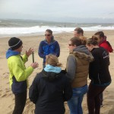
Why a Level 2 Coach should manage the Session
Most Clubs will have developed good and safe processes for delivery of training sessions by applying experience and common sense. Nothing wrong with that! The issue is that if something goes wrong, how do we demonstrate that it is uniformly to a documented and established best practice standard, as the law expects?
The Level 2 Coach is our uniform system to establish that what we all do is to a current best practice standard. It is an established and proven framework by which we can show that, if followed, is an acceptable way of managing the risk
A Level 2 Coach will ensure that a Lifeguard has undertaken the risk assessment, that there is safety cover that meets the requirements of the National Safety Guide, that safeguarding protocols have been met, that all on the session are fit and any medical conditions are known, that parent/ guardian approval has been given, that first aid cover is available, that there is a EAP and back up if needed – And that the session plan is within the ability of those involved and that there is suitable equipment and helpers and that the session will deliver a progressive individual development opportunity with feed back. Most of all, that the session is fun and meets expectations. There is also the widely misunderstood question of helpers, assistants and the Level 1 coach. Firstly, a Level 1 Coach is only qualified to assist, not to lead and should at all times be directly supervised by a Level 2 Coach. Sessions led by Level 1 Coaches without the attendance of a Level 2 Coach should not be happening. As to assistants and helpers, they are essential but by their very nature, mostly unqualified and for the good of all need to be well supported and managed. Many need instruction to be useful. This is one of the key roles of the Level 2 Coach.
Most of Club training sessions now are to service the needs of our 2700 Nipper members. Their needs in particular require a fully managed approach to a uniformly high standard and whilst many Clubs will have addressed this, a qualified Level 2 Coach in charge will do everything that the duty of care requires supported by safety cover as required and very clearly set out in the National Safety Guide, an excellent and still valid requirement. Other training at different age groups should be no different just because people involved are older.
How to mange the Risk
Our view is that what we do as Clubs and as an NGB is inherently high risk and we have no alternative as Life Savers but to do the best we can to ensure that training is run to the highest standards. The law sees it this way and the recently revised policies of the Health and Safety Executive certainly do. After several leisure park drowning’s and loss of life at Triathlon/ Open water events resulting in pending prosecution of those in charge, HSE have indicated that whatever the circumstances, if a proper duty of care is not applied they will punitively fine and where necessary send to prison those who are found wanting. Past judgements have recognised limitations of small organisations and tended to be sympathetic to those who are voluntary. This is now not the way future judgements will be applied and regardless of size or resources ALL are required to apply a uniformly high standard following best practice. There is now no defence in saying we did our best or it was what we always did. In the worst case this could mean direct attacks on Club officers and even members with risk of prison and punitive fines. Not a risk worth taking when it is relatively easy to avoid.

Lauren Turner
SLSGB Educator.

