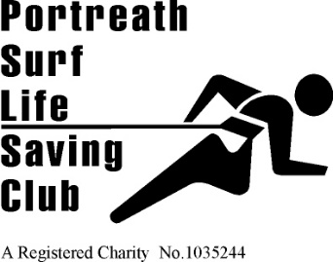 | 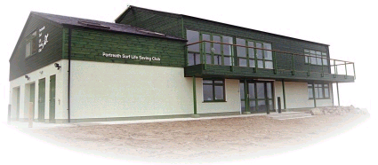 | Founded 1958  Affiliated to  Surf Life Saving Cornwall and the Surf Life Saving Association of Great Britain  HEADQUARTERS  Portreath Beach, Portreath, Cornwall UK.  WEBSITE  www.portreathslsc.co.uk

63rd Annual General Meeting of Portreath Surf Life Saving Club.
Saturday, 27th November 2021

Agenda

Members present

Apologies

Minutes of 2020 AGM

Reports

Election of Club Officers

Changes to Club Constitution

Membership fees

Close of Meeting

Open Forum.

