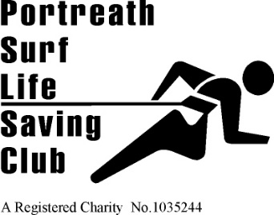 | 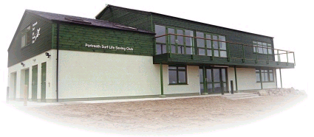 | Founded 1958  Affiliated to  Surf Life Saving Cornwall and the Surf Life Saving Association of Great Britain  HEADQUARTERS  Portreath Beach, Portreath, Cornwall UK.  Tel. 07808 912273  WEBSITE  www.portreathslsc.co.uk

61st Annual General Meeting of Portreath Surf Life Saving Club.
2.00pm Sunday, 17th November 2019.

Agenda

Members present

Apologies

Minutes of 2018 AGM

Reports

Election of Club Officers

Changes to Club Constitution

Membership fees

Nominations to Life Membership

Close of Meeting

Open Forum.

