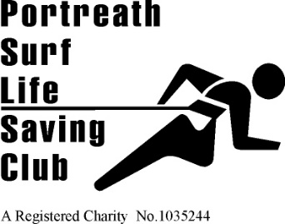 | 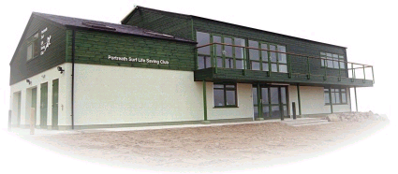 | Founded 1958  Affiliated to  Surf Life Saving Cornwall and the Surf Life Saving Association of Great Britain  HEADQUARTERS  Portreath Beach, Portreath, Cornwall UK.  Tel. 01209 842746  WEBSITE  www.portreathslsc.org.uk

Committee Position: Nomination Form

Nomination and Consent by Nominee

I declare that I am a current senior member (over the age of 18) of Portreath Surf Life Saving Club and that I wish to nominate myself for the Club Committee.
If elected, I consent to act as a committee member of the club , undertake to fulfil all duties and obligations required of the position, including the obligations to attend meetings of the committee and to become appropriately conversant with the duties of committee members.

I wish to nominate myself for the position of:
Chairman | Vice Chairman | Honorary Secretary | Honorary Treasurer | Club  Captain | Safe Guarding Officer # 1

(Please clearly indicate the position for which you are willing to stand eg place X in appropriate box.

Name (PRINT) | Membership # | Signed | Date

PROPOSER SECONDER

Name (Print)
Member No
Signed
Date

NB The nomination may only be proposed and seconded by fully paid club senior members over the age of 18, including Life Members.

Please note it is your responsibility to get your nomination proposed and seconded prior to submitting your nomination

Please forward this nomination to the Secretary – either by email to

dianegreen@freenetname.co.uk

or via post to:

‘Glendene’ 11, Glenfeadon Terrace, Portreath TR16 4JX

The nomination must be received by the Secretary no later than 7 days before the date of the meeting at which the positions are to be determined.

Closing date Sunday 10th November 2019.

Official Use Only

Membership status check:
Club Membership paid? Yes / No
Date Received: ______________________

